# Project Management System

This document outlines the implementation of the webAPI for Project Management System

1. **Requirement**

1. PMS contains information about projects and tasks. Every task belongs to some project. Task can contain subtasks and project can contain subprojects.

* 1. 2. For every project following attributes are stored in PMS:
  2. a. Code
  3. b. Name
  4. c. Start date
  5. d. Finish date
  6. e. State
  7. 3. For every task following attributes are stored in PMS:
  8. a. Name
  9. b. Description
  10. c. Start date
  11. d. Finish date
  12. e. State
  13. 4. State of task is set when task is updated and can be one of the following values: Planned, inProgress, Completed 5. State of project is always calculated by the following rules:
  14. a. Completed, if all tasks in the project and its subprojects have state Completed
  15. b. inProgress, if there is at least one task with state inProgress in project or its subprojects
  16. c. Planned in all other cases

1. **Database Schema Diagram:**

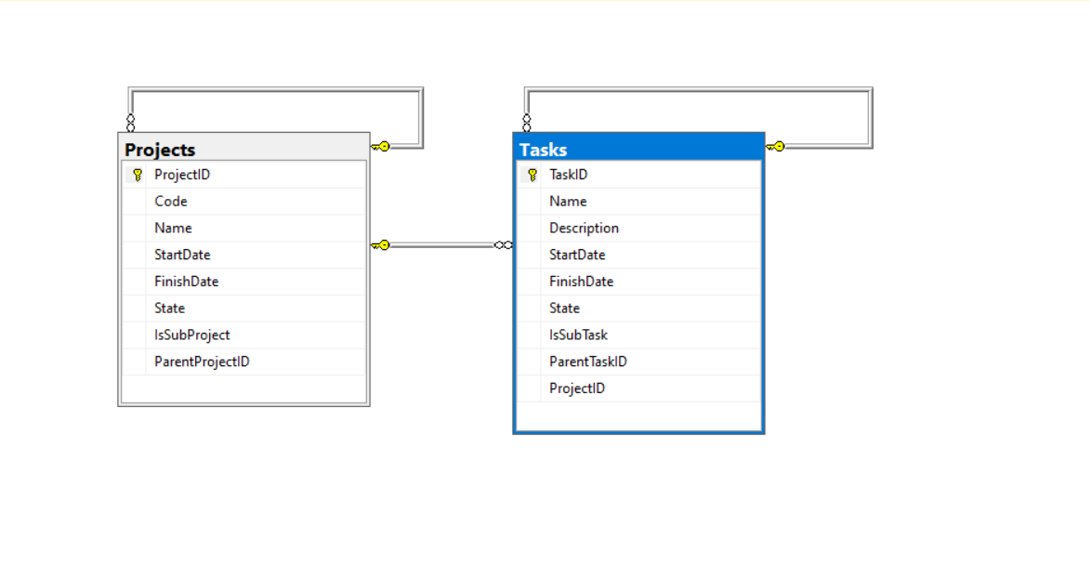

1. **Web API Functions**
   1. Fetch Functions
      1. api/GetProject

This Function fetches entire list for Projects and its child elements from database

* + 1. api/GetProject/{id}

This Function fetches projects, sub-projects, task, sub-task from database having Project {id} passed as an attribute

* + 1. api/GetDetailsForInprogress/{dateString}

This Function fetches projects, sub-projects for Projects and task from database

* + 1. api/GetTask

This Function fetches entire list for Task and its sub-task from database

* + 1. api/GetTask/{id}

This Function fetches entire list for Task and its sub-task from database having task {id} passed as an attribute

* 1. Insert Functions
     1. api/CreateNewProject

This Function Creates a New Project or Sub-Project

* + 1. api/CreateNewTask

This Function Creates a New Task or Sub-Task

* 1. Update Functions
     1. api/UpdateProject

This Function Updates a Project or Sub-Project

* + 1. api/UpdateTask

This Function Updates a Task or Sub-Task

* 1. Delete Functions
     1. api/DeleteProject/{id}

This Function Deletes a Project its dependent Sub-Project and tasks

* + 1. api/DeleteTask/{id}

This Function Deletes a task its dependent Sub-task

1. **Database Scripts:**

In Package Manager Console execute command **update-database.** This will create database **pms** in SQL server (connection string mentioned in web.config)

Also Execute Sql file PMS_SP.sql in SQL Server Management